EMPLOYEE DATABASE

Query 1: Creating and displaying tables
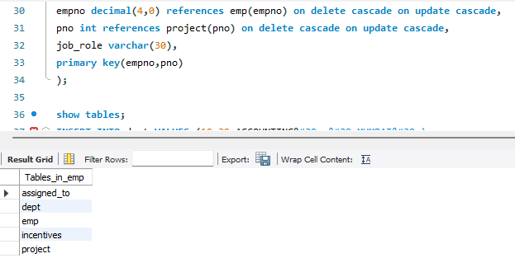
Query 2: Inserting values into tables
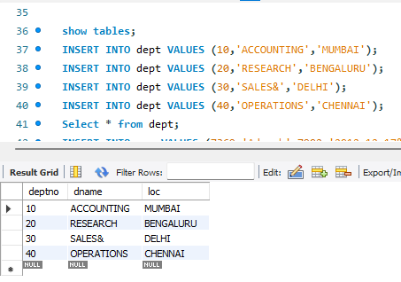
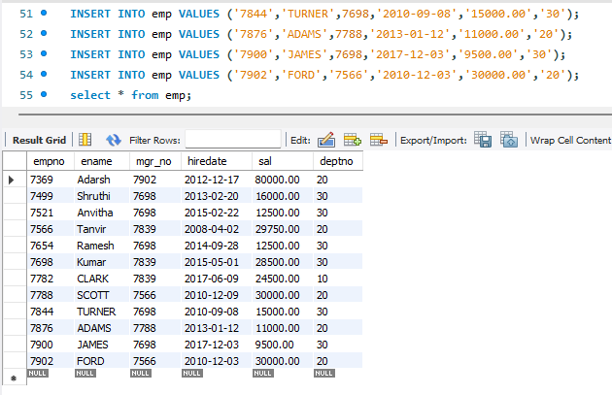
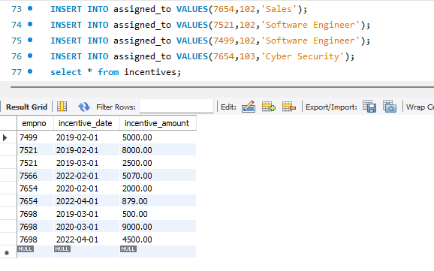
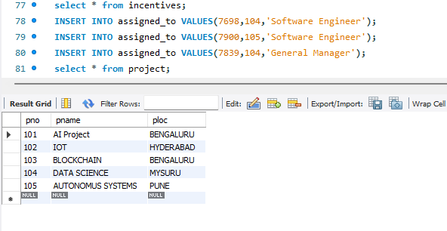
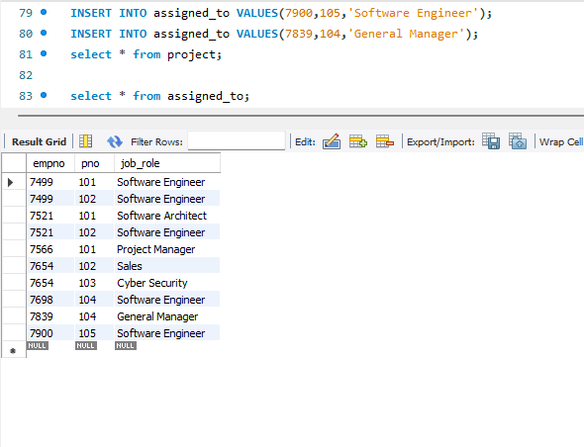
Query 3: Retrieve the employee numbers of all employees who work on project located in Bengaluru, Hyderabad, or Mysuru.
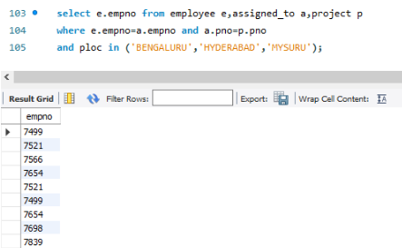
Query 4: Get Employee ID’s of those employees who didn’t receive incentives
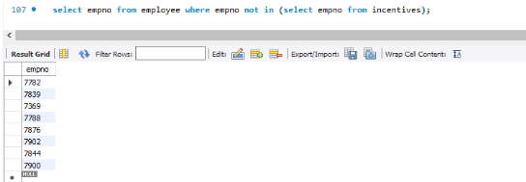

Query 5: Write a SQL query to find the employees name, number, dept, job_role, department location and project location who are working for a project location same as his/her department location.
